Shaik Abdhul Faheem
192321068

1.Demonstration of Control Statements and Loops in R
x &lt;- 1
y &lt;- x + 5
result &lt;- 0
# If condition
if (x &gt; 0) {
result &lt;- x * 2
} else {
result &lt;- x / 2
}
# For loop
for (j in 1:5) {
result &lt;- result + j
}
# While loop
k &lt;- 1
while (k &lt;= 5) {
result &lt;- result + k
k &lt;- k + 1
}
# Repeat loop
m &lt;- 1
repeat {
result &lt;- result + m
m &lt;- m + 1
if (m &gt; 3) {
break
}
}
# Switch control statement

choice &lt;- x %% 3
output &lt;- switch(choice,
&quot;0&quot; = &quot;Divisible by 3&quot;,
&quot;1&quot; = &quot;Remainder 1&quot;,
&quot;2&quot; = &quot;Remainder 2&quot;)
# Display output
print(paste(&quot;Program 1 Result:&quot;, result))
print(output)

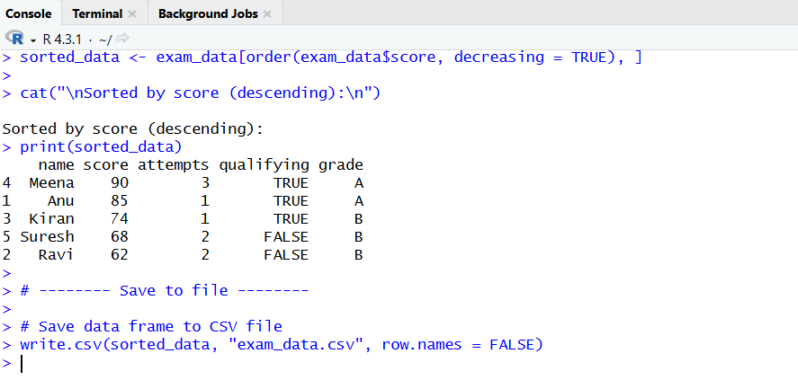

2.Create labeled matrices (5×4, 3×3, 2×2) filled by row/column.
# 5x4 matrix filled by row
mat_5x4_row <- matrix(
data = 1:20,
nrow = 5,
ncol = 4,
byrow = TRUE,
dimnames = list(
paste("R", 1:5, sep = ""),
paste("C", 1:4, sep = "")
)
)

# 3x3 matrix filled by column
mat_3x3_col <- matrix(
data = 1:9,
nrow = 3,
ncol = 3,
byrow = FALSE,
dimnames = list(
paste("R", 1:3, sep = ""),
paste("C", 1:3, sep = "")
)
)

# 2x2 matrix filled by row
mat_2x2_row <- matrix(
data = 1:4,
nrow = 2,
ncol = 2,
byrow = TRUE,
dimnames = list(
c("Row1", "Row2"),
c("Col1", "Col2")
)
)

# Display matrices
cat("5x4 Matrix (Filled by Row):\n")
print(mat_5x4_row)

cat("\n3x3 Matrix (Filled by Column):\n")
print(mat_3x3_col)

cat("\n2x2 Matrix (Filled by Row):\n")
print(mat_2x2_row)

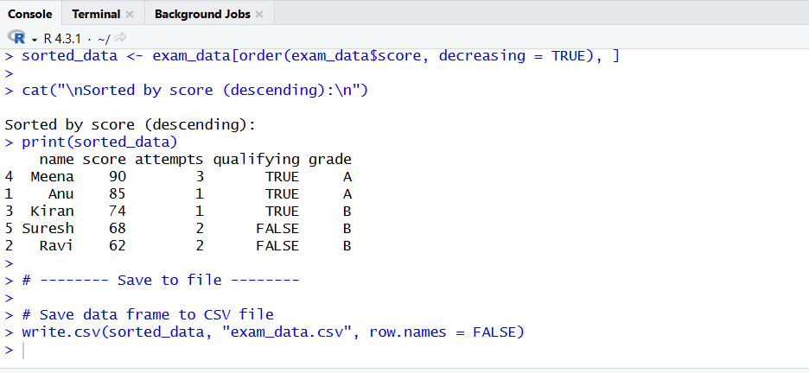

3.Write an R program to create and display a 3D array with specified rows, columns, and tables.
for (i in 1:100) {
if (i %% 3 == 0 && i %% 5 == 0) {
cat("FizzBuzz\n")
} else if (i %% 3 == 0) {
cat("Fizz\n")
} else if (i %% 5 == 0) {
cat("Buzz\n")
} else {
cat(i, "\n")
}
}
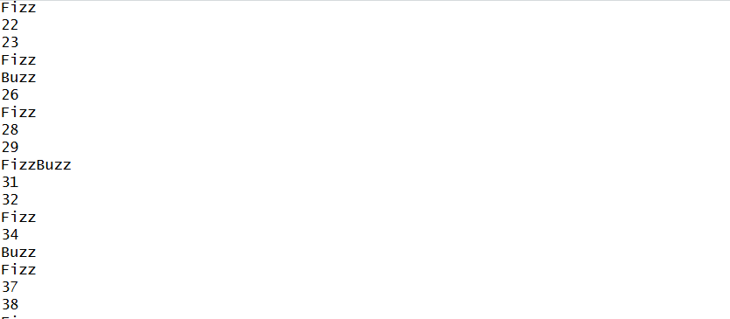

4.Create arrays from vectors with dimension names, print specific elements.
# Create a vector
vec <- c(10, 20, 30, 40, 50, 60, 70, 80)

# Create an array from the vector (2 rows, 2 columns, 2 tables)
arr <- array(
data = vec,
dim = c(2, 2, 2),
dimnames = list(
c("R1", "R2"), # Row names
c("C1", "C2"), # Column names
c("T1", "T2") # Table names
)
)

# Display the array
print(arr)

# Print specific elements
cat("\nSpecific Elements:\n")

# Element from Row R2, Column C1, Table T1
print(arr["R2", "C1", "T1"])

# Element from Row R1, Column C2, Table T2
print(arr["R1", "C2", "T2"])
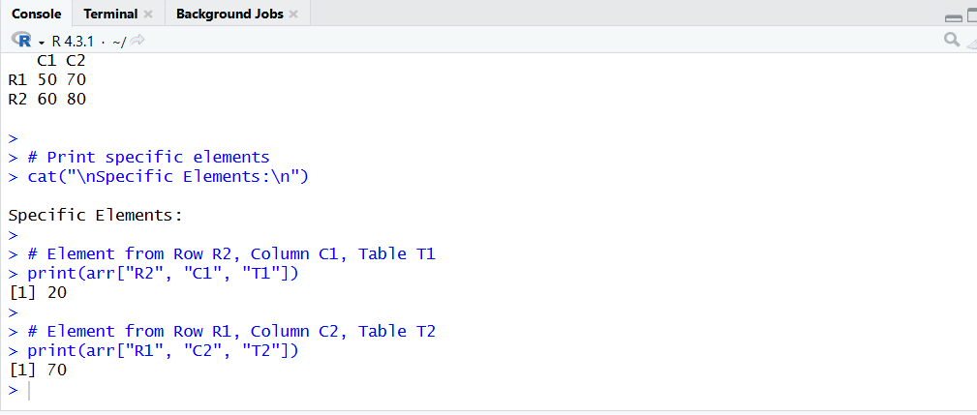

5.Create and manipulate factor variables (e.g., women’s dataset heights, random LETTERS sample).
# Using women's dataset (heights)
data(women)

# Convert heights into a factor (Low / Medium / High)
height_factor <- cut(
women$height,
breaks = c(58, 62, 66, 72),
labels = c("Low", "Medium", "High")
)

# Display factor details
cat("Height Factor:\n")
print(height_factor)
cat("\nLevels of Height Factor:\n")
print(levels(height_factor))

# Create a random sample from LETTERS
set.seed(10)
letter_sample <- sample(LETTERS[1:5], 10, replace = TRUE)

# Convert to factor
letter_factor <- factor(letter_sample)

# Display factor details
cat("\nLetter Factor:\n")
print(letter_factor)
cat("\nLevels of Letter Factor:\n")
print(levels(letter_factor))
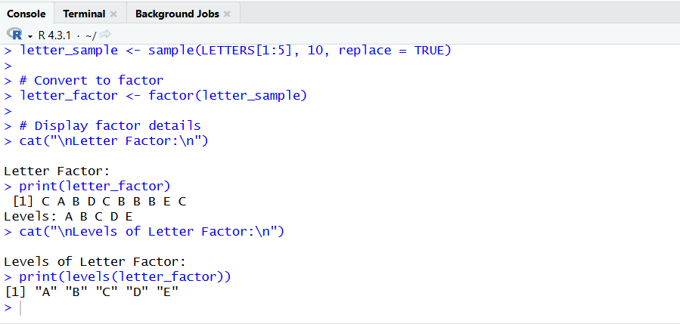

6.Create an R list containing vectors, matrices, and functions; display contents.
# # Create a numeric vector
num_vector <- c(5, 10, 15, 20)

# Create a matrix
num_matrix <- matrix(
data = 1:6,
nrow = 2,
ncol = 3,
byrow = TRUE
)

# Create a function
square_function <- function(x) {
x * x
}

# Create a list containing vector, matrix, and function
my_list <- list(
Vector = num_vector,
Matrix = num_matrix,
Function = square_function
)

# Display the list
print(my_list)

# Use the function from the list
cat("\nUsing function from the list:\n")
print(my_list$Function(4))
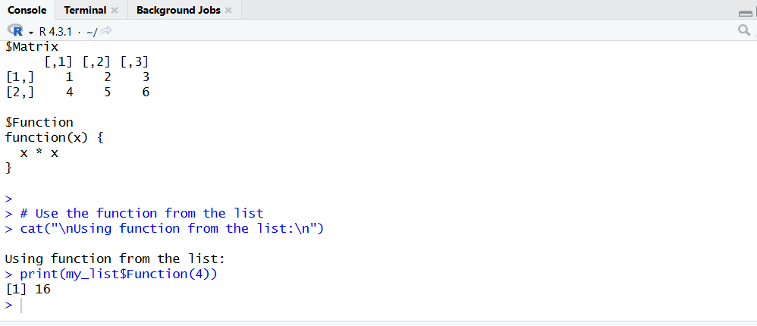

7.Write R programs for basic tasks: Factors of a number, generate a vector of 10 random integers between -50 and 50, print numbers 1–100 with FizzBuzz logic.
# Input number
num <- 36

# Find factors
cat("Factors of", num, "are:\n")
for (i in 1:num) {
if (num %% i == 0) {
cat(i, " ")
}
}
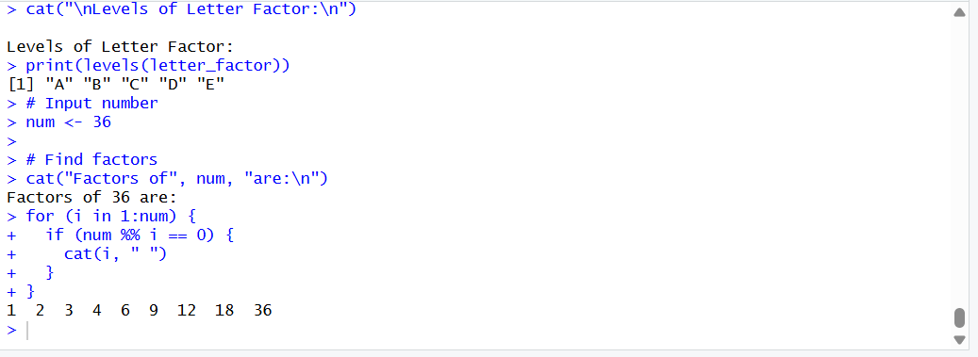
8.Generate random numbers from a normal distribution; count occurrences.
# Generate 50 random numbers from a normal distribution
set.seed(1)
norm_data <- rnorm(50, mean = 0, sd = 1)

# Convert values into rounded classes
rounded_data <- round(norm_data)

# Count occurrences
occurrences <- table(rounded_data)

# Display results
cat("Random Normal Numbers (rounded):\n")
print(rounded_data)

cat("\nOccurrences of values:\n")
print(occurrences)

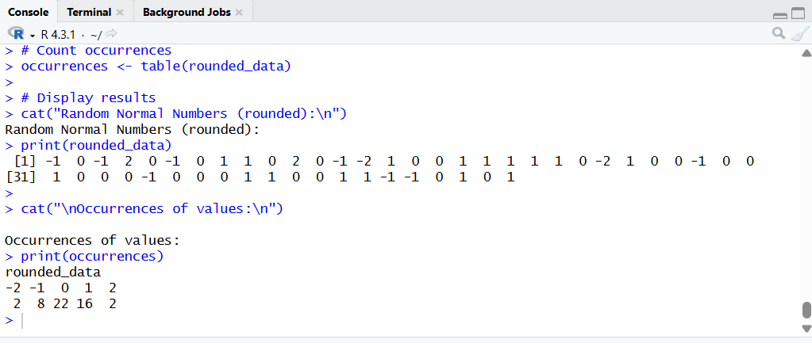

9.Create empty plots with specified axis limits.

# Create an empty plot with x and y axis limits
plot(
x = c(0, 10),
y = c(0, 100),
type = "n", # 'n' means no points are plotted
xlab = "X Axis",
ylab = "Y Axis",
main = "Empty Plot with Axis Limits"
)
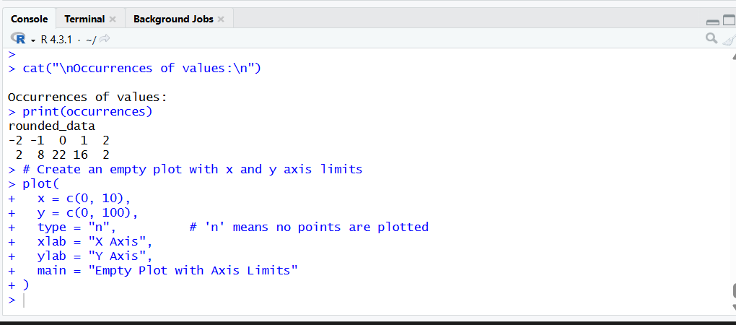

10.Create and explore a data frame exam_data with name, score, attempts, and qualifying fields. Perform extract, add row/column, sort, save to file.
# Create the data frame
exam_data <- data.frame(
name = c("Anu", "Ravi", "Kiran", "Meena"),
score = c(85, 62, 74, 90),
attempts = c(1, 2, 1, 3),
qualifying = c(TRUE, FALSE, TRUE, TRUE)
)

# Display data frame
print(exam_data)

# -------- Extract operations --------

# Extract score column
cat("\nScores:\n")
print(exam_data$score)

# Extract rows where score > 70
cat("\nStudents with score > 70:\n")
print(exam_data[exam_data$score > 70, ])

# -------- Add new column --------

# Add grade column
exam_data$grade <- ifelse(exam_data$score >= 75, "A", "B")

cat("\nAfter adding grade column:\n")
print(exam_data)

# -------- Add new row --------

# Add a new student
exam_data[nrow(exam_data) + 1, ] <- list("Suresh", 68, 2, FALSE, "B")

cat("\nAfter adding new row:\n")
print(exam_data)

# -------- Sort data frame --------

# Sort by score (descending)
sorted_data <- exam_data[order(exam_data$score, decreasing = TRUE), ]

cat("\nSorted by score (descending):\n")
print(sorted_data)

# -------- Save to file --------

# Save data frame to CSV file
write.csv(sorted_data, "exam_data.csv", row.names = FALSE)
